**THE BOIS: DIAGNOSING DENGUE INFECTION BY USING AN INTELLIGENT SYSTEM**

Muhammad Haikal Iman Bin Osman (A179376), Mohamad Saiful Nizam Bin Abd Aziz (A179830), Dineswaran A/L Navarasan (A180763), Dr. Kerk Yi Wen (Instructor)

______________________________________________________________________________

**Abstract.** Dengue is a viral infection found in tropical and sub-tropical climates worldwide, mostly in urban areas. It is an infection transmitted to humans through the bite of infected mosquitoes which is classified as Aedes. A fuzzy system is a knowledge-based system that can reach a right conclusion utilizing specific data from individual patients. It is one of the most frequent forms of artificial intelligence in the medical system. A set of rules are used for representing the knowledge or data of dengue fever. Therefore, it is important to detect dengue disease at an early stage. The designed fuzzy system can be used for early diagnosis of dengue disease of a patient by using physical symptoms as input variables and converting these input variables into fuzzy membership functions. A promising forecast of dengue can spare an individual’s life by making them aware of their health and be wary of the symptoms faced. In this task, we propose to build up an AI model to foresee dengue fever. We will use different classifiers in Weka to run and the calculation giving the most elevated forecast precision will be considered as the suitable model for our dataset.  
***Keywords.*** *Dengue, Aedes, Pattern recognition, Fuzzy modeling, Diagnosing Dengue Infection, Intelligent System.*

*______________________________________________________________________________*

**INTRODUCTION**  
 Dengue fever is a contagious illness. High fevers, headaches, rashes, and pain all over the body are all possible symptoms. Dengue viruses are transmitted to humans through the bite of an infected Aedes mosquito, such as Aedes aegypti or Aedes albopictus. Dengue fever affects over half of the world's population, or about 4 billion people. Dengue fever is a common cause of sickness in high-risk settings. Dengue fever infects up to 400 million people each year. Approximately 100 million individuals are infected, with 40,000 people dying from severe dengue fever.Dengue fever is caused by one of four closely related viruses: dengue virus 1, 2, 3, or 4. As a result, a person can contract the dengue virus up to four times over his or her lifetime. The goal of this Artificial Intelligence (AI) research is to assist individuals in diagnosing dengue symptoms. According to the statistics from the paper, symptoms normally start four to six days after infection and can continue up to 10 days. Sudden high fever, severe headaches, discomfort behind the eyes, severe joint and muscular pain, weariness, nausea, vomiting, skin rash that emerges two to five days after the commencement of the fever, and light bleeding such as nasal bleeds, bleeding gums, and easy bruising are the first signs.

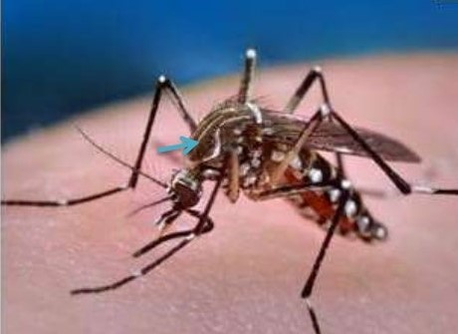  
**Figure 1. Aedes aegypti.**  
 Symptoms might be modest, and they can be mistaken for the flu or another viral infection. The virus affects younger children and persons who have never had it before in a milder way than it does older children and adults. However, major issues can arise.  
 Dengue hemorrhagic fever is an uncommon complication marked by a high temperature, damage to lymph and blood arteries, bleeding from the nose and mouth, liver enlargement, and circulatory system failure. Massive bleeding, shock, and death may occur as a result of the symptoms. The condition is known as dengue shock syndrome (DSS).  
 We may use AI to create a model, such as a Decision Tree, to achieve the desired result with a high level of accuracy. A dataset of 100 patient records will be included into the model, with the outcome being either positive or negative. General information about the patient, as well as bodily components such as severe headache, joint muscle discomfort, stomach pain, and body temperature, are among the qualities. A point-by-point representation of the dataset is used. We intend to build a model that achieves an accuracy rate of greater than 95% and works well with our dataset.

**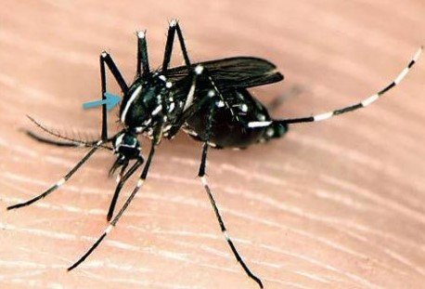  
Figure 2. Aedes albopictus**

**METHOD**

**KNOWLEDGE EXTRACTION**

The domain for our group project is medical and the name for this project is Diagnosing Dengue Infection. There are a few websites that we use for this project and the website that we referred to is:-Dengue fever by Mary Anne Dunkin. We acquired our dataset from:-Typhoid and dengue fever symptoms by Ashish Cawla. The dataset used to train our dengue prediction model was gathered from actual medical data of patients containing the symptoms and physical changes experienced during the time of infection such as body temperature, eye pain and joint muscle ache. These attributes as a whole are being used in our model so that the learning can be done by the system to predict the presence of dengue fever. The dataset provides possible information about the symptoms that could have led to dengue fever and showed the final result of whether the dengue fever is present or not, which makes it a dependent variable. Finally, the dataset isstructured data because the dataset can be represented in rows and columns.

**KNOWLEDGE REPRESENTATION**

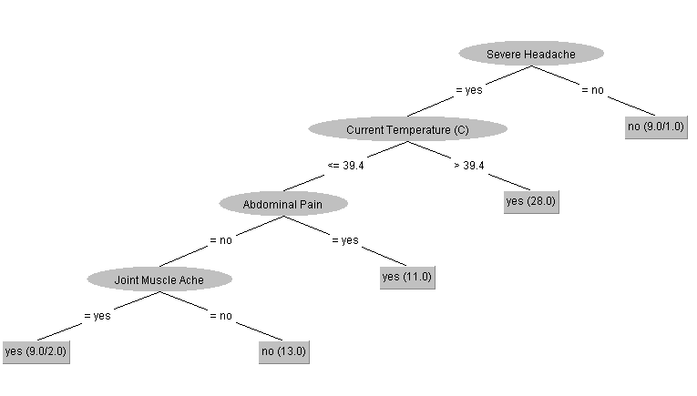

**Figure 3. The Tree Generated From J48 Machine Learning Model.**

Rule 1: IF Severe Headache is no THEN dengue fever is false.

Rule 2: IF Severe Headache is yes AND Current Temperature is >39.4 THEN Dengue Fever is true.

Rule 3: IF Severe Headache is yes AND Current Temperature is <=39.4 AND Abdominal Pain is yes THEN Dengue Fever is true.

Rule 4: IF Severe Headache is yes AND Current Temperature is <=39.4 AND Abdominal Pain is no AND Joint Muscle Ache is no THEN Dengue Fever is false.

Rule 5: IF Severe Headache is yes AND Current Temperature is <=39.4 AND Abdominal Pain is no AND Joint Muscle Ache is yes THEN Dengue Fever is true.

Using the Weka Explorer in the classifier section, we have used Cross-validation as our test option and set the fold value into 10 so our dataset of 100 patients will be divided randomly into 10 parts. Cross-validation is primarily used in applied machine learning to estimate the skill of a machine learning model on unseen data.

**INFERENCE ENGINE**

For our project, we have used backward chaining as the inference engine. Backward chaining is a method used when a description is given backward from the goal, and in this case the dengue fever status of someone. In this kind of chaining, the right arrangements can be inferred successfully if pre-decided principles are met by the inference engine. Our system uses a bottom-up approach so the dengue fever status will be given based on the input from the users. Users would need to answer all the given questions which are based on their body symptoms and their health condition. The system will filter all the possibilities and finally conclude the users’ possible dengue fever status.

**HANDLING UNCERTAINTIES AND CONFLICTING KNOWLEDGE BASE**

| **Linguistic Variable** | **Linguistic Value** | **Range** | **Fuzzy Representation** |
| --- | --- | --- | --- |
| Abdominal Pain Membership Functions | No Abdominal Pain_Upper  No Abdominal Pain_Lower  Yes Abdominal Pain_Upper  Yes Abdominal Pain_Lower | [0.0 , 0.0 , 10.0]  [0.0 , 0.0 , 8.0]  [0.0 , 10.0 , 10.0]  [2.0 , 10.0 , 10.0] |  |
| Joint Muscle Ache Membership Functions | No Joint Muscle Ache_Upper  No Joint Muscle Ache_Lower  Yes Joint Muscle Ache_Upper  Yes Joint Muscle Ache_Lower | [0.0 , 0.0 , 6.0]  [0.0 , 0.0 , 8.0]  [2.0 , 10.0 , 10.0]  [4.0 , 10.0 , 10.0] |  |
| Dengue Result Membership Functions | No Dengue_Upper  No Dengue_Lower  Yes Dengue_Upper  Yes Dengue_Lower | [0.0 , 6.0]  [0.0 , 4.0]  [30.0 , 6.0]  [30.0 , 4.0] |  |
| Interval Type-2 Fuzzy Logic System Control Surface for Dengue Example | | |  |

**Table 2. The Fuzzification Process.**

*“The Abdominal Pain was: 7.0. The Joint Muscle Ache was: 8.0. Using center of sets type reduction, the IT2 FLS recommends a dengue of: 26.058535533520647. Using centroid type reduction, the IT2 FLS recommends a tip of: 25.62382102348451. Centroid of the output for DENGUE (based on centroid type reduction). left = 24.663531580328375 and right = 26.58411046664065 at y= 1.0. The Abdominal Pain was: 0.0. The Joint Muscle Ache was: 0.0. Using center of sets type reduction, the IT2 FLS recommends a dengue of: 3.9414644664793532. Using centroid type reduction, the IT2 FLS recommends a tip of: 3.9414644664793532. Centroid of the output for DENGUE (based on centroid type reduction). left = 3.091579932090684 and right = 4.791349000868022 at y= 1.0*

*Interval Type-2 Fuzzy Logic System with 4 rules:*

*IF No Abdominal Pain AND No Joint Muscle Ache THEN No Dengue Result*

*IF No Abdominal Pain AND Yes Joint Muscle Ache THEN Yes Dengue Result*

*IF Yes Abdominal Pain AND No Joint Muscle Ache THEN Yes Dengue Result*

*IF Yes Abdominal Pain AND Yes Joint Muscle Ache THEN Yes Dengue Result”*

***Output 1. The Backtracking of The Fuzzification Process.***

**THE MACHINE LEARNING TECHNIQUES**

We utilized three machine learning techniques in our task. HoeffdingTree, REPTree and Decision Tree (J48) were picked to prepare our model with dengue information. Machine learning technique that we use in our project is the decision tree (J48) because this model is very commonly used by every data scientist and machine learning engineer and also produces the highest dengue dataset classification accuracy out of the 3 models used. If the instances belong to the same class, the J48 algorithm comprises numerous steps where the leaf is labelled with a comparable class. The potential data for each attribute will be calculated, and the gain in data will be calculated from the attribute test. Finally, based on the current selection parameter, the best characteristic will be picked. The J48 decision tree can handle data with specific properties as well as lost or incomplete attribute estimations. It also provides a more accurate portrayal and is easier to comprehend.

**RESULTS - DIAGRAM AND TABLE**

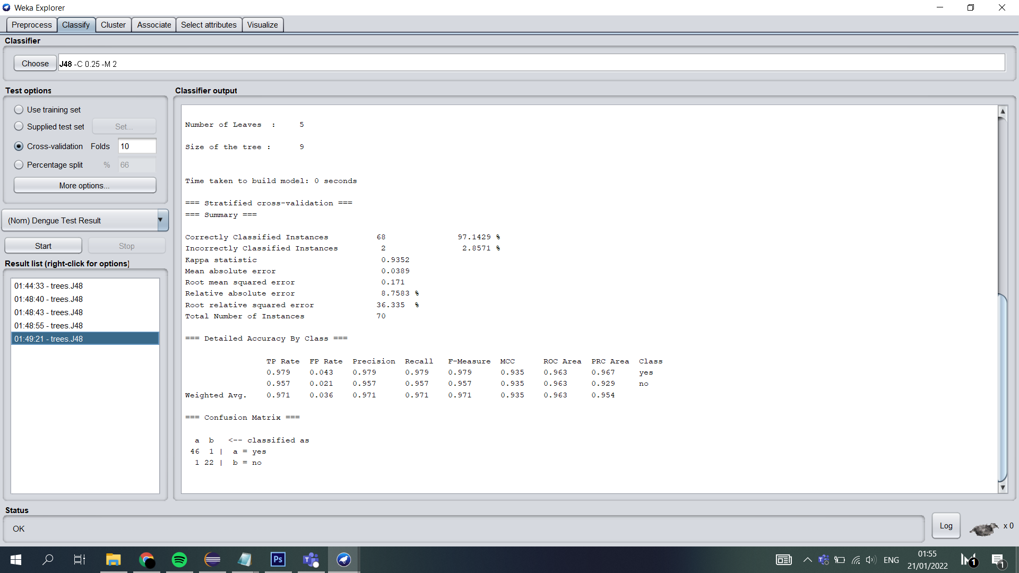  
**Figure 4. The diagram above shows the result of the decision tree (J48) based on our dataset.**

**DIAGRAM AND TABLE**

**INTERFACE - INPUT & OUTPUT**

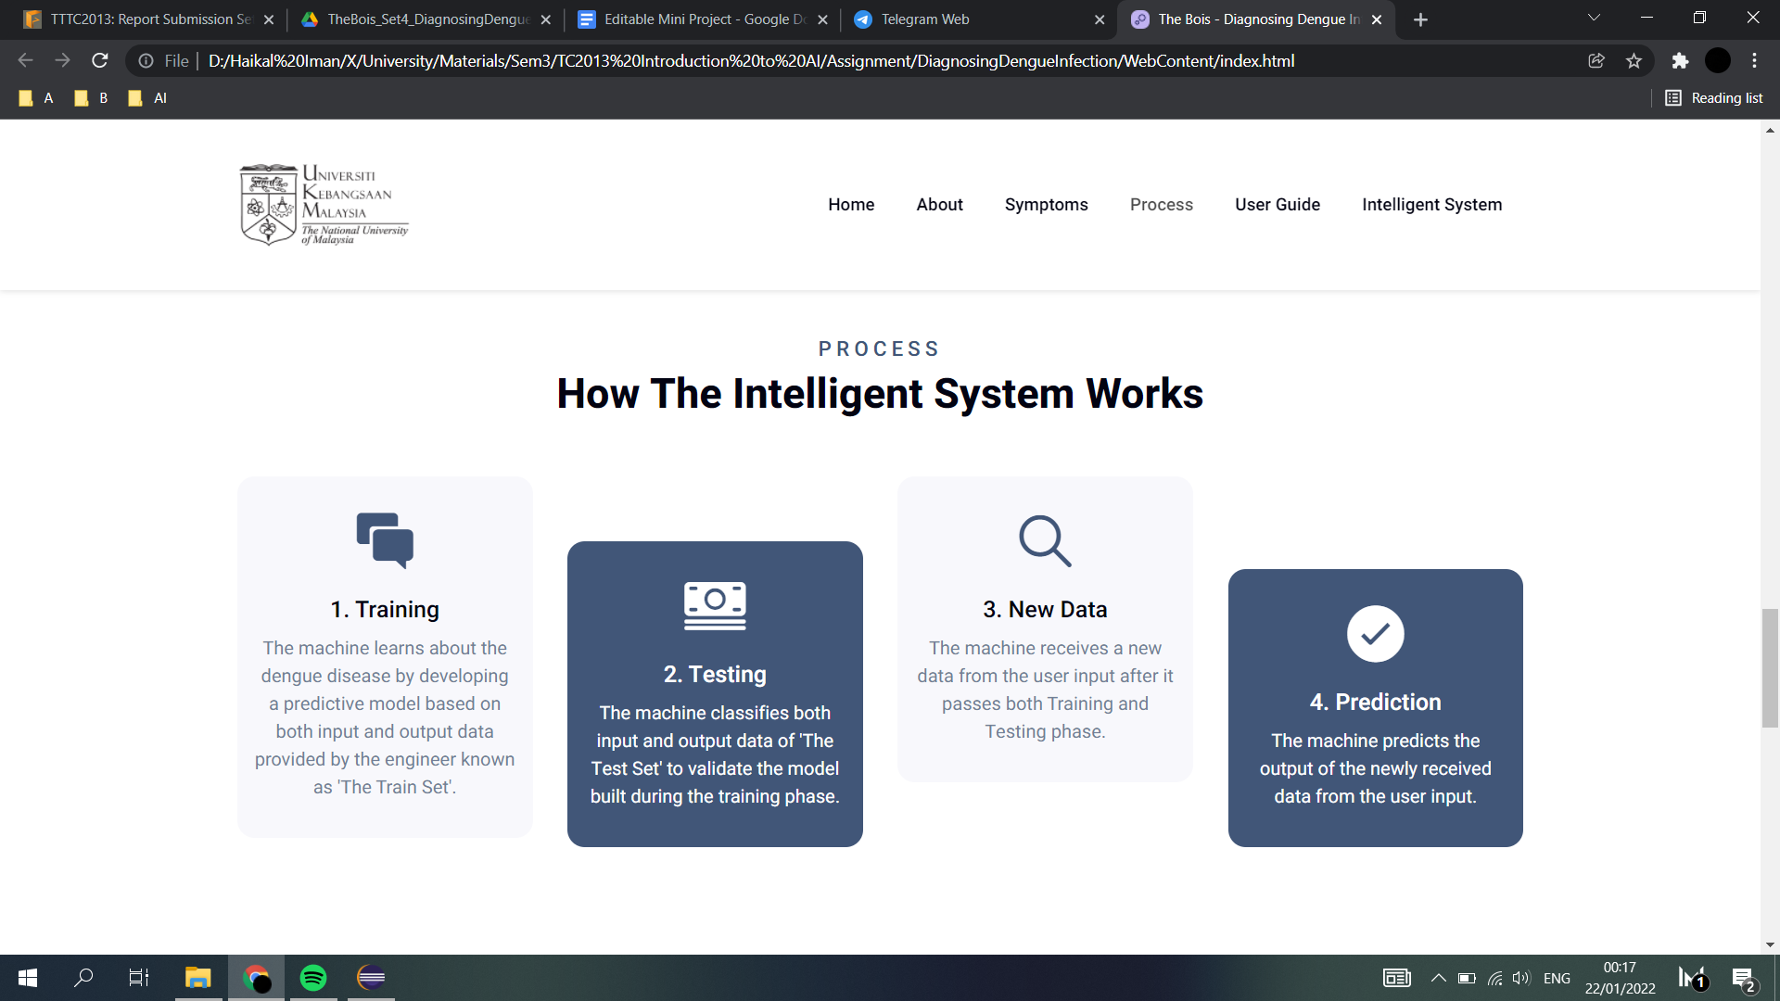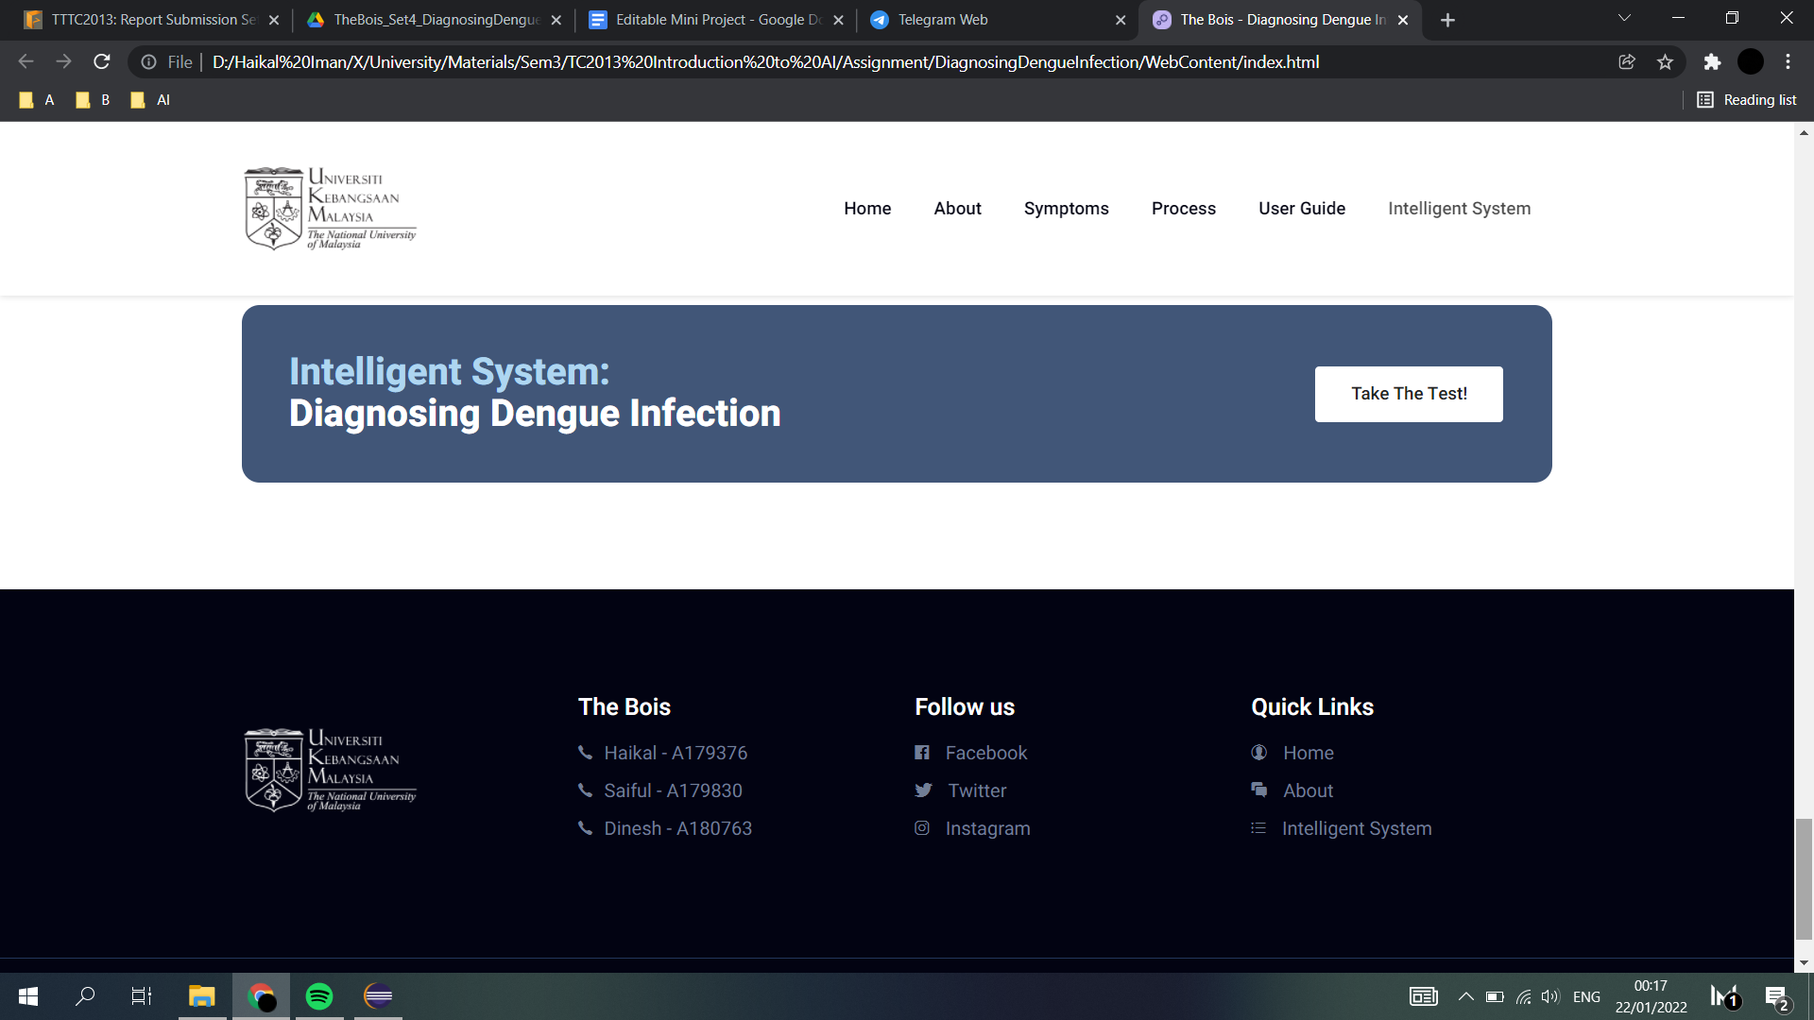

**Figure 5. The diagram above shows the input and the output of diagnosing dengue infection.**

**Figure 6. The following is the code for the input and output generated.**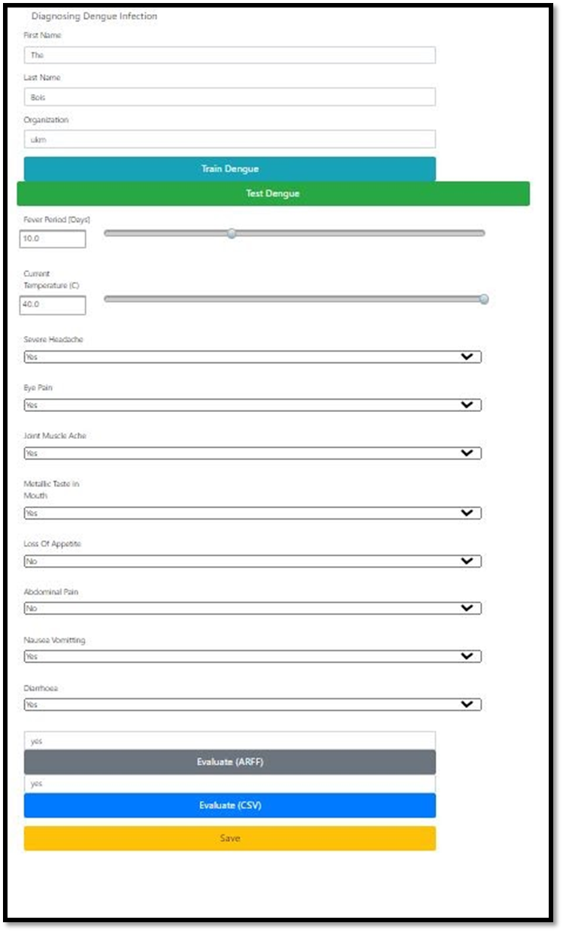

*After adding an instance*

*--------------------------*

*@relation TestInstances*

*@attribute 'Fever Period' numeric*

*@attribute 'Current Temperature (C)' numeric*

*@attribute 'Severe Headache' {yes,no}*

*@attribute 'Eye Pain' {no,yes}*

*@attribute 'Joint Muscle Ache' {yes,no}*

*@attribute 'Metallic Taste In Mouth' {no,yes}*

*@attribute 'Loss Of Appetite' {no,yes}*

*@attribute 'Abdominal Pain' {no,yes}*

*@attribute 'Nausea & Vomiting' {yes,no}*

*@attribute Diarrhoea {no,yes}*

*@attribute 'Dengue Test Result' {yes,no}*

*@data*

*10,40,yes,yes,yes,yes,no,no,yes,yes,yes*

*--------------------------*

*Index of predicted class label: 0.0, which corresponds to class: Dengue Test Result*

*prediction, yes*

*Backtracking - train*

*J48 pruned tree*

*------------------*

*Metallic Taste In Mouth = no*

*| Eye Pain = no*

*| | Joint Muscle Ache = yes: yes (16.0/1.0)*

*| | Joint Muscle Ache = no*

*| | | Current Temperature (C) <= 38.3: no (6.0)*

*| | | Current Temperature (C) > 38.3: yes (5.0)*

*| Eye Pain = yes: no (15.0)*

*Metallic Taste In Mouth = yes: yes (21.0)*

*Number of Leaves : 5*

*Size of the tree : 9*

*J48 pruned tree*

*------------------*

*Severe Headache = yes*

*| Current Temperature (C) <= 39.4*

*| | Abdominal Pain = no*

*| | | Joint Muscle Ache = yes: yes (8.0/2.0)*

*| | | Joint Muscle Ache = no: no (11.0)*

*| | Abdominal Pain = yes: yes (10.0)*

*| Current Temperature (C) > 39.4: yes (26.0)*

*Severe Headache = no: no (8.0/1.0)*

*Number of Leaves : 5*

*Size of the tree : 9*

*J48 pruned tree*

*------------------*

*Eye Pain = no*

*| Abdominal Pain = no*

*| | Current Temperature (C) <= 38.3*

*| | | Joint Muscle Ache = yes: yes (2.0)*

*| | | Joint Muscle Ache = no: no (5.0)*

*| | Current Temperature (C) > 38.3: yes (16.0/1.0)*

*| Abdominal Pain = yes: yes (21.0)*

*Eye Pain = yes*

*| Metallic Taste In Mouth = no: no (14.0)*

*| Metallic Taste In Mouth = yes: yes (5.0)*

*Number of Leaves : 6*

*Size of the tree : 11*

*J48 pruned tree*

*------------------*

*Metallic Taste In Mouth = no*

*| Eye Pain = no*

*| | Abdominal Pain = no*

*| | | Joint Muscle Ache = yes: yes (11.0/1.0)*

*| | | Joint Muscle Ache = no: no (6.0)*

*| | Abdominal Pain = yes: yes (11.0)*

*| Eye Pain = yes: no (14.0)*

*Metallic Taste In Mouth = yes: yes (21.0)*

*Number of Leaves : 5*

*Size of the tree : 9*

*J48 pruned tree*

*------------------*

*Eye Pain = no*

*| Abdominal Pain = no*

*| | Current Temperature (C) <= 38.3*

*| | | Joint Muscle Ache = yes: yes (2.0)*

*| | | Joint Muscle Ache = no: no (5.0)*

*| | Current Temperature (C) > 38.3: yes (16.0/1.0)*

*| Abdominal Pain = yes: yes (21.0)*

*Eye Pain = yes*

*| Metallic Taste In Mouth = no: no (14.0)*

*| Metallic Taste In Mouth = yes: yes (5.0)*

*Number of Leaves : 6*

*Size of the tree : 11*

*J48 pruned tree*

*------------------*

*Eye Pain = no*

*| Current Temperature (C) <= 38.3*

*| | Abdominal Pain = no: no (7.0/1.0)*

*| | Abdominal Pain = yes: yes (9.0)*

*| Current Temperature (C) > 38.3: yes (26.0)*

*Eye Pain = yes*

*| Metallic Taste In Mouth = no: no (16.0)*

*| Metallic Taste In Mouth = yes: yes (5.0)*

*Number of Leaves : 5*

*Size of the tree : 9*

*J48 pruned tree*

*------------------*

*Severe Headache = yes*

*| Current Temperature (C) <= 39.4*

*| | Eye Pain = no*

*| | | Fever Period <= 3: no (4.0)*

*| | | Fever Period > 3: yes (18.0/2.0)*

*| | Eye Pain = yes: no (7.0)*

*| Current Temperature (C) > 39.4: yes (26.0)*

*Severe Headache = no: no (8.0/1.0)*

*Number of Leaves : 5*

*Size of the tree : 9*

*J48 pruned tree*

*------------------*

*Eye Pain = no*

*| Abdominal Pain = no*

*| | Current Temperature (C) <= 38.3*

*| | | Joint Muscle Ache = yes: yes (2.0)*

*| | | Joint Muscle Ache = no: no (5.0)*

*| | Current Temperature (C) > 38.3: yes (15.0/1.0)*

*| Abdominal Pain = yes: yes (21.0)*

*Eye Pain = yes*

*| Metallic Taste In Mouth = no: no (15.0)*

*| Metallic Taste In Mouth = yes: yes (5.0)*

*Number of Leaves : 6*

*Size of the tree : 11*

*J48 pruned tree*

*------------------*

*Metallic Taste In Mouth = no*

*| Eye Pain = no*

*| | Abdominal Pain = no*

*| | | Joint Muscle Ache = yes: yes (11.0/1.0)*

*| | | Joint Muscle Ache = no: no (6.0)*

*| | Abdominal Pain = yes: yes (11.0)*

*| Eye Pain = yes: no (14.0)*

*Metallic Taste In Mouth = yes: yes (21.0)*

*Number of Leaves : 5*

*Size of the tree : 9*

*J48 pruned tree*

*------------------*

*Severe Headache = yes*

*| Abdominal Pain = no*

*| | Current Temperature (C) <= 38.3*

*| | | Joint Muscle Ache = yes: yes (2.0)*

*| | | Joint Muscle Ache = no: no (10.0)*

*| | Current Temperature (C) > 38.3*

*| | | Current Temperature (C) <= 39.4*

*| | | | Nausea & Vomiting = yes: yes (5.0)*

*| | | | Nausea & Vomiting = no: no (2.0)*

*| | | Current Temperature (C) > 39.4: yes (15.0)*

*| Abdominal Pain = yes: yes (21.0)*

*Severe Headache = no: no (8.0)*

*Number of Leaves : 7*

*Size of the tree : 13*

*Accuracy of J48: 94.29%*

*---------------------------------*

*Reading Weather Details -*

*Fever Period 0.0*

*Current Temperature (C) 0.0*

*Severe Headache yes*

*Eye Pain yes*

*Joint Muscle Ache yes*

*Metallic Taste In Mouth yes*

*Loss of Appetite yes*

*Abdominal Pain yes*

*Nausea & Vomiting yes*

*Diarrhoea yes*

*Accuracy: 94.28571428571429*

*Backtracking - test*

*Confusion Matrix*

*========*

*a b <-- classified as*

*19 1 | a = yes*

*3 7 | b = no*

*Accuracy of J48: 86.67%*

*---------------------------------*

*Reading Weather Details -*

*Fever Period 0.0*

*Current Temperature (C) 0.0*

*Severe Headache yes*

*Eye Pain yes*

*Joint Muscle Ache yes*

*Metallic Taste In Mouth yes*

*Loss of Appetite yes*

*Abdominal Pain yes*

*Nausea & Vomiting yes*

*Diarrhoea yes*

*Accuracy: 86.66666666666667*

**Output 2.Backtracking.**

For the backtracking, our dataset was divided randomly into 10 parts as the value of the cross-validation folds is 10. In Java, every part has its own percentage and the final accuracy percentage is shown by calculating the average percentage of each and every part. In Weka, the final accuracy percentage is shown by considering the most parts that are similar to each other and calculating the average percentage from them. As for the test backtracking, line 10 to line 20 can be deleted because it is only showing the default values for every attribute.

**ACCURACY**

**Figure 7. Accuracy by using J48 classifier.**



**Figure 8. Accuracy by using HoeffdingTREE.**

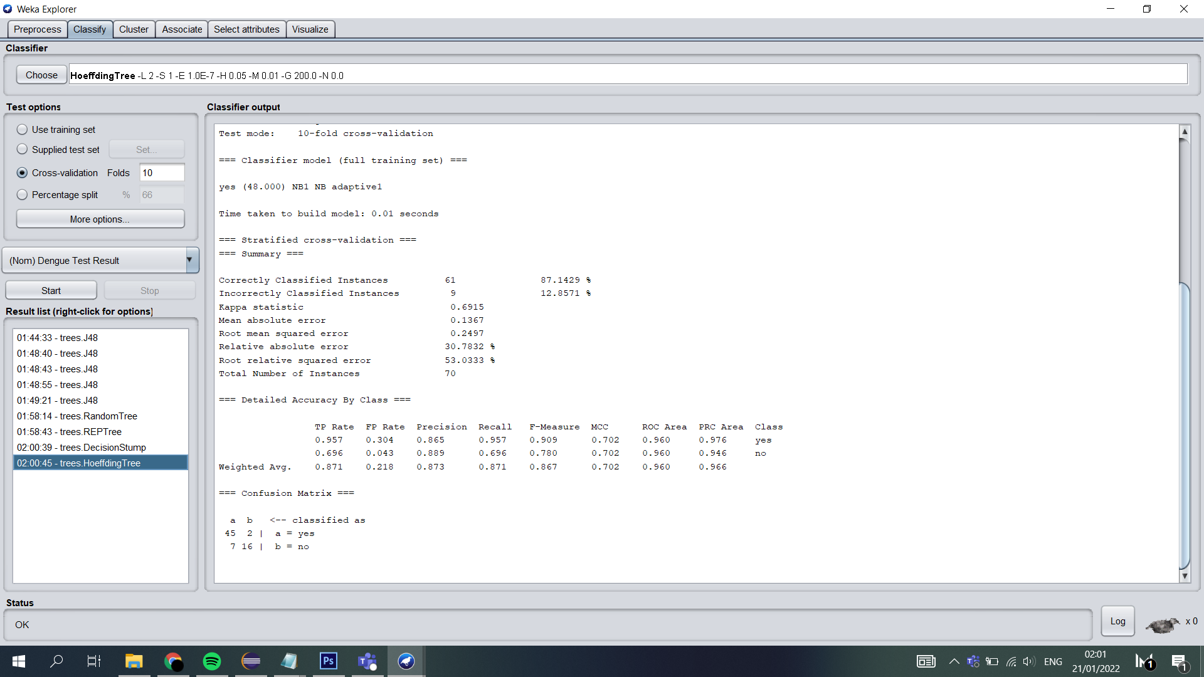

**Figure 9. Accuracy by using REPTree.**

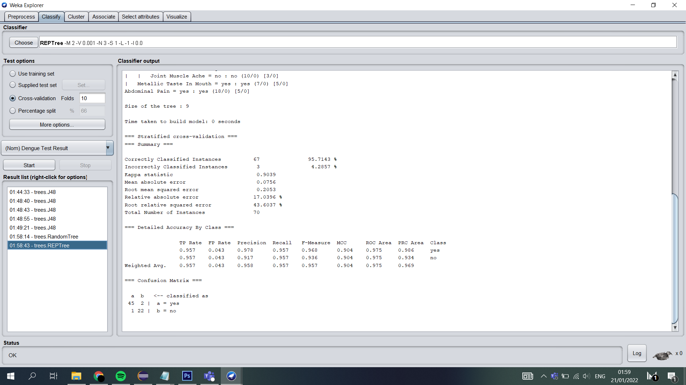

| Indicators | J48 | HoeffdingTree | REPTree |
| --- | --- | --- | --- |
| Classification Accuracy | 97.14% | 87.14% | 95.71% |
| Kappa statistic | 0.9352 | 0.6915 | 0.9039 |
| Mean absolute error | 0.0389 | 0.1367 | 0.0756 |
| Root mean squared error | 0.1710 | 0.2497 | 0.2053 |

**Table 3. The accuracy comparison of J48, HoeffdingTree, and REPTree.**

Hence, we have chosen the J48 classifier model for our project as it provides the most accurate predictions based on our data which is 97.14% and has the Kappa statistic of 0.9352 which is considered almost perfect agreement in accuracy. It is also easier to visualize the patterns of the attributes as this technique constructs a tree to model the classification process. The other two classifier models, HoeffdingTree and REPTree only provide 87.14% and 95.71% accuracy and the representation of our data using these two models are a bit complicated and not related to the output that we expected.

**ANALYSIS**

**KNOWLEDGE ACQUISITION CHALLENGES**

The challenges that we have been through was to search for our data. We need to find the best dataset for our project by using the kangle website. We need to clean data to increase overall productivity and allow for the highest quality information in your decision-making. Benefits include: Removal of errors when multiple sources of data are at play. Fewer errors make for less-frustrated.

**EXPLANATION ABOUT THE RULES AND CERTAINTY FACTORS OBTAINED**

Based on the dataset that we got, the tree was generated from the weka. The rules were obtained from the tree during the pre-processing step. From the pre-processing step, we use the formula to calculate the certainty factor.

*Certainty Factor (cf) Formula:*

*cf = The accuracy of J48 model = 97.14*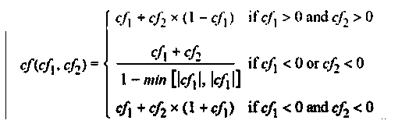

**SAMPLE PROVING OF CASE FROM THE FACTS AND RULES OBTAINED**

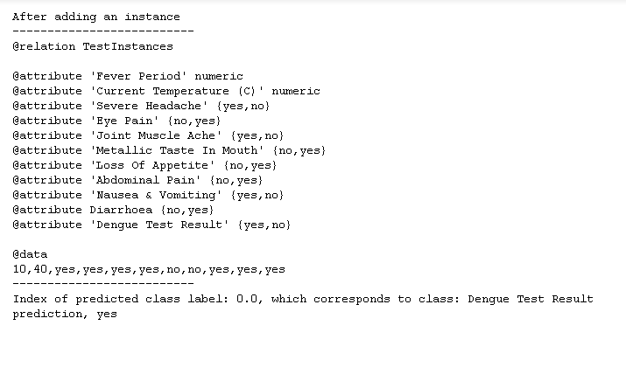

**Figure 10. The sample proving of case from the facts and rules.**

**CONCLUSION**

On the whole, there are many artificial intelligence techniques that can be used to resolve the problem. From the experience of preparing dengue fever models utilizing AI calculations, we increase adequate information about the working and usage of them. Artificial Intelligence is widely used in the field of medication and medicinal services. The intensity of the forecast of illness and the widespread of figuring and information will be the future in different clinical situations. Concerning dengue fever, we have now experienced the working and showing of three AI calculations which are REPTree, HoeffdingTree and J48. The REPTree created a decent accuracy of 95.71% while the HoeffdingTree has an accuracy of 87.14%. However, the J48 model performed better for our situation with 97.14% accuracy. All things considered, we can conclude that the J48 model would be the best appropriate calculation for dengue forecast. Plus, knowing the consequence of whether the disease is available or not utilizing an individual web interface increases the value of the model.

**CONTRIBUTION OF MEMBER**

Muhammad Haikal Iman bin Osman (A179376), a sophomore in Computer Science (Honours) at The National University of Malaysia (UKM). The Mobile Application Development Club (MAD Club) member - currently involved as the head programmer in the Diagnosing Dengue Infection research by using the Artificial Intelligence (A.I). Responsible for both the front and back-end of the intelligent system.

Mohamad Saiful Nizam bin Abd Aziz(A179830), currently studying bachelor of Computer Science (Honours) at The National University of Malaysia (UKM). One of the sports and recreation Exco in PERTAMA. Computer science student with aptitude for information systems analysis and computer programming currently involved in Diagnosing Dengue Infection research by using the Artificial Intelligence (A.I). Responsible for Fuzzy logic and journalism

Dineswaran A/L Navarasan(A180763), 2nd year student in Computer Science (Honours) at The National University of Malaysia (UKM). Member of the Autonomous Robot and Vision Systems (ARVIS) and currently involved in Diagnosing Dengue Infection research by using the Artificial Intelligence (A.I.). Responsible for data collection and report analysis.  
 All team members had participated committedly in the making of the intelligent system and the journal report on Diagnosing Dengue Infection.



**Figure 11. From left to right - Haikal, Saiful, Dinesh.**

**REFERENCE**

Dunkin, M. A. (n.d.). *Dengue fever: Symptoms, causes, and treatments*. WebMD. Retrieved January 21, 2022, from <https://www.webmd.com/a-to-z-guides/dengue-fever-reference>

*Typhoid and dengue fever symptoms dataset: Data Science and Machine Learning*. Kaggle. (n.d.). Retrieved January 21, 2022, from <https://www.kaggle.com/general/91461>

*Forward chaining and backward chaining in AI - Javatpoint*. www.javatpoint.com. (n.d.). Retrieved January 21, 2022, from <https://www.javatpoint.com/forward-chaining-and-backward-chaining-in-ai>

Dikran Marsupial, Wayne, & Md. Sabbir Ahmed. (1961, February 1). *Why do researchers use 10-fold cross validation instead of testing on a validation set?* Cross Validated. Retrieved January 21, 2022, from <https://stats.stackexchange.com/questions/49692/why-do-researchers-use-10-fold-cross-validation-instead-of-testing-on-a-validati>

What is fuzzy logic in AI and what are its applications? Edureka. (2019, December 10). Retrieved January 21, 2022, from <https://www.edureka.co/blog/fuzzy-logic-ai/>

*Weka datasets, classifier and J48 algorithm for Decision Tree*. Software Testing Help. (2022, January 5). Retrieved January 21, 2022, from <https://www.softwaretestinghelp.com/weka-datasets/>